Cameron Frison

15 August 2021

Web Development with HTML and CSS

Prof Sue Sampson

Module 2 HTML doc

Starter code errors shown besides an autocorrect of the last </ on the last </html> due to vs code correcting it.

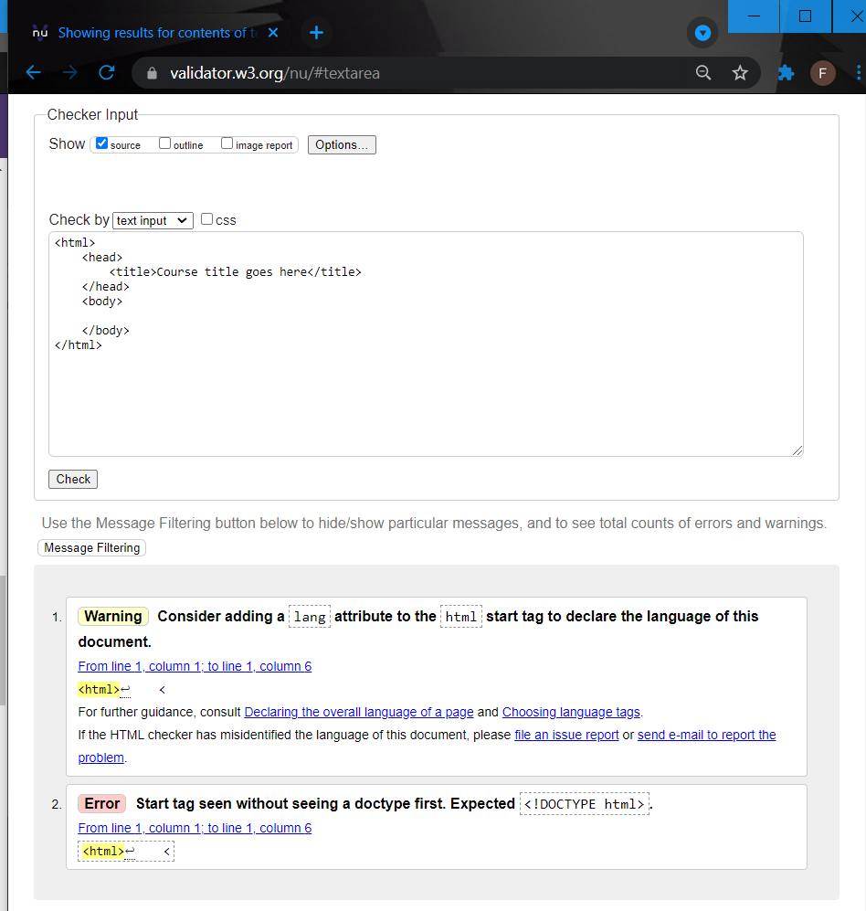

After checking for errors and clearing all errors from the starter code

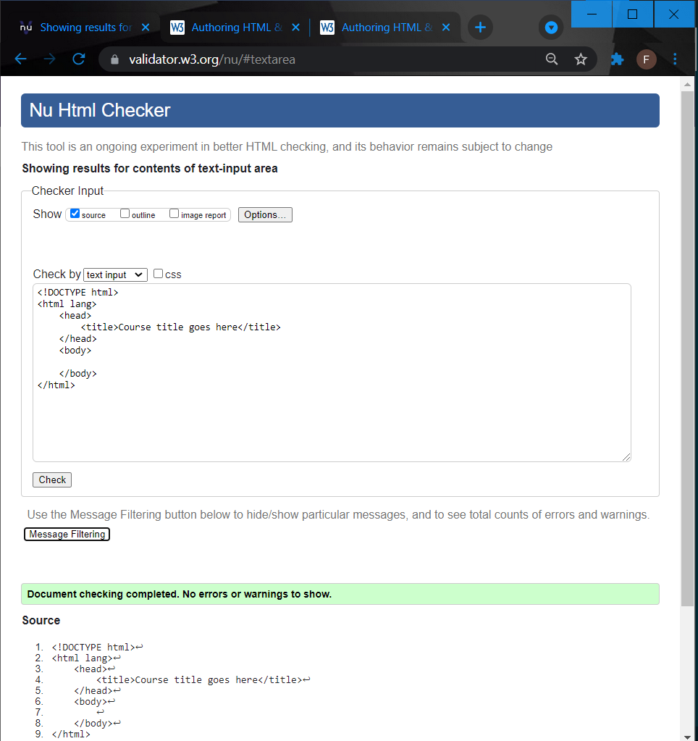

After updating the title and body and checking through the validator

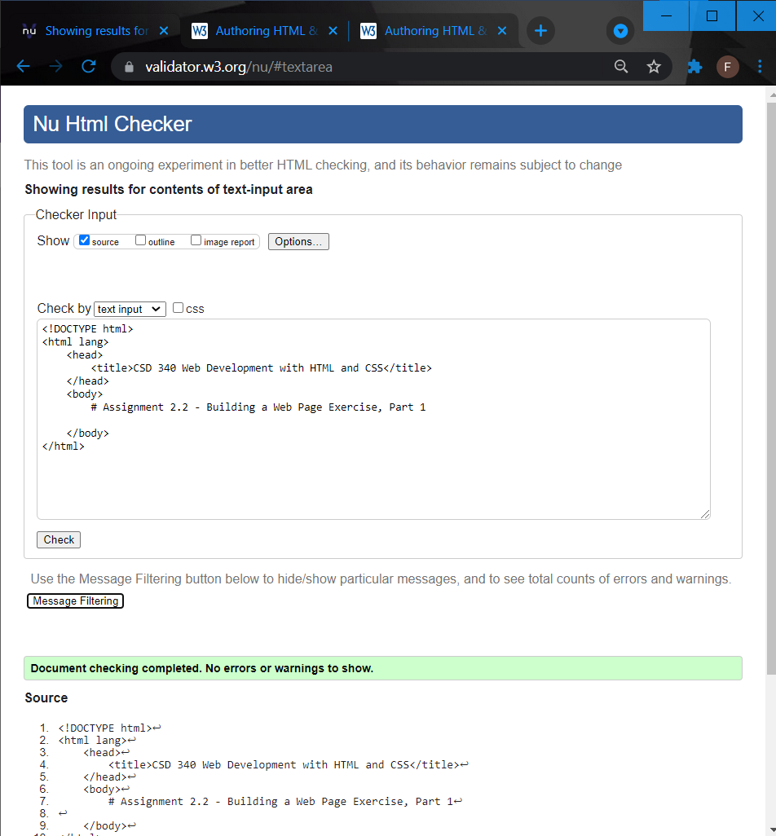

After I realized I messed up the header and lang section

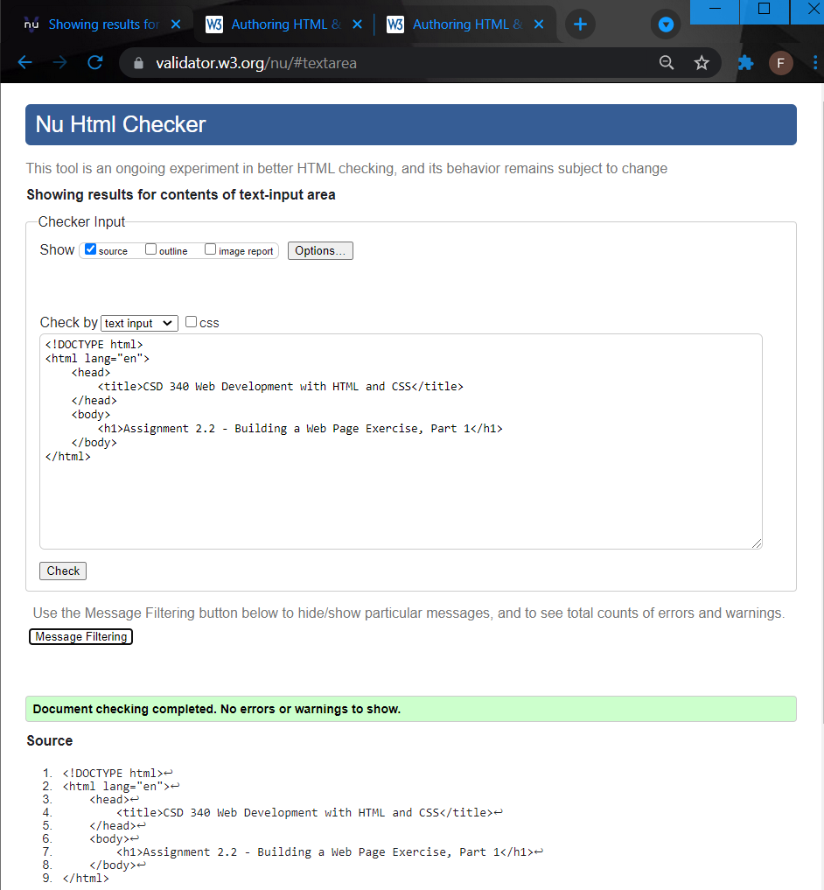

Final look at the website

